# Adjust Visualization

## Filtering

Check “set axis width and bin values based on axis below” to filter with user-inputs

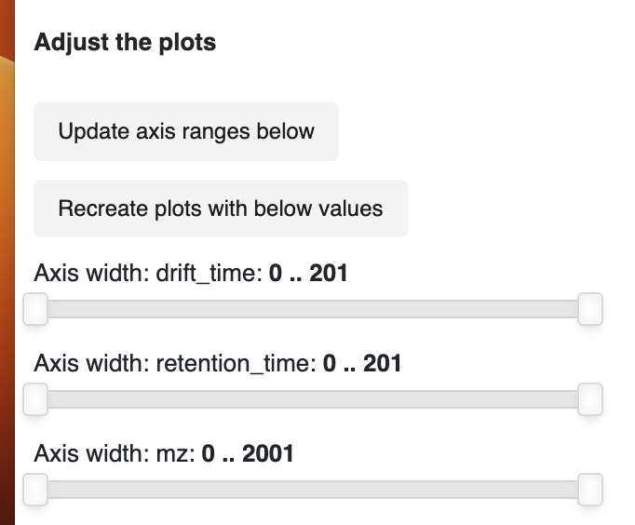

If the box isn’t checked, zooming is possible via the plot input “zoom”



Min spacing sets the minimum size of the grid during rasterizing

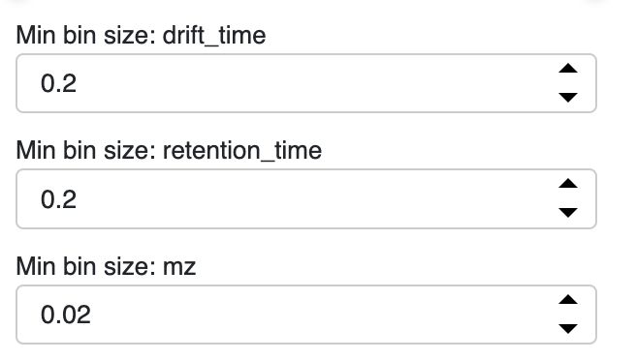

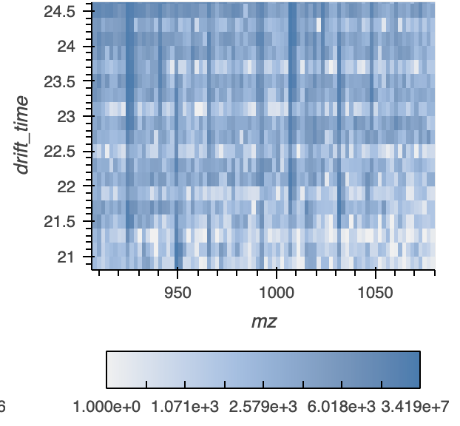

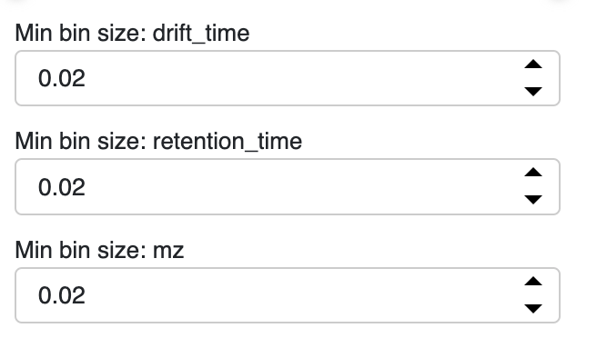

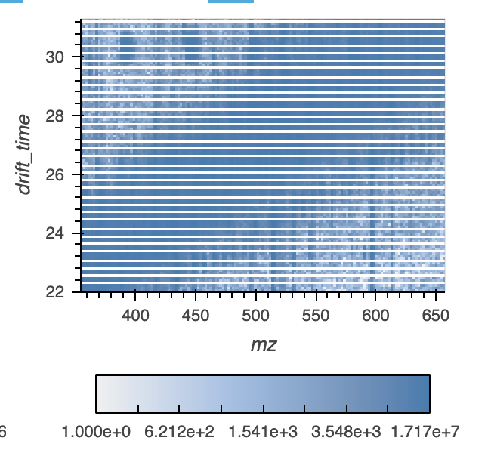

The user can zoom into new areas of the chart with the user-input widgets, and the aggregation and colormap level will automatically update, allowing the user to inspect the data on an overview level or a focused area. We disabled the re-aggregation when the user zoomed in using the toolbar to only trigger re-aggregation if the user choses to refresh the plots with the manual axis widths

Linked Selection will filter on the underlying data, even if they aren’t used in the plot



# Column Name Selection

The names of the data can be updated here:

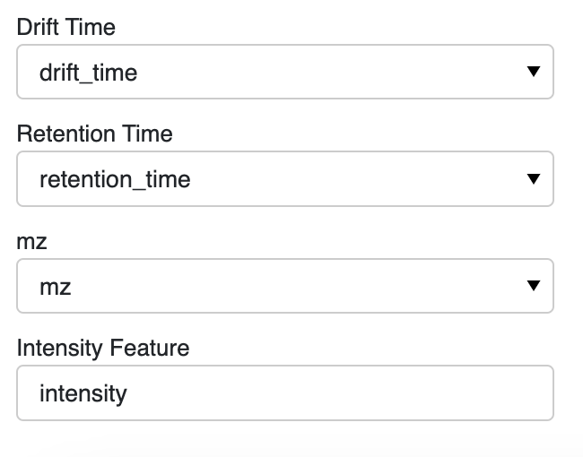

If the initial data is mzML, the user needs to select the names from the file to use as the retention and drift time

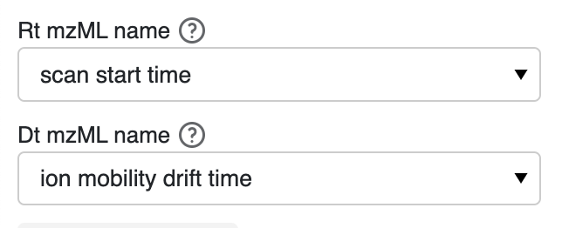

# Selecting Data

Select the files from the folder indicated in the “location of data folder” folder

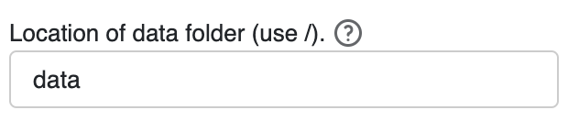

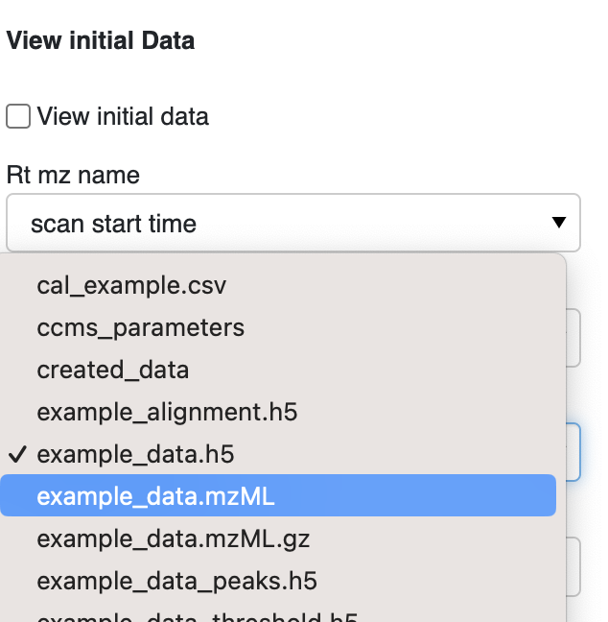

The initial data is a placeholder

# Smooth data:

The original data is a placeholder. Unchecking it will run rerun the function with the selected data.

Click 'Run smooth' after updating parameters to get new graph.

Keeping the smooth radius small and increasing number of iterations is preferable to a larger smoothing radius, albeit at greater computational expense

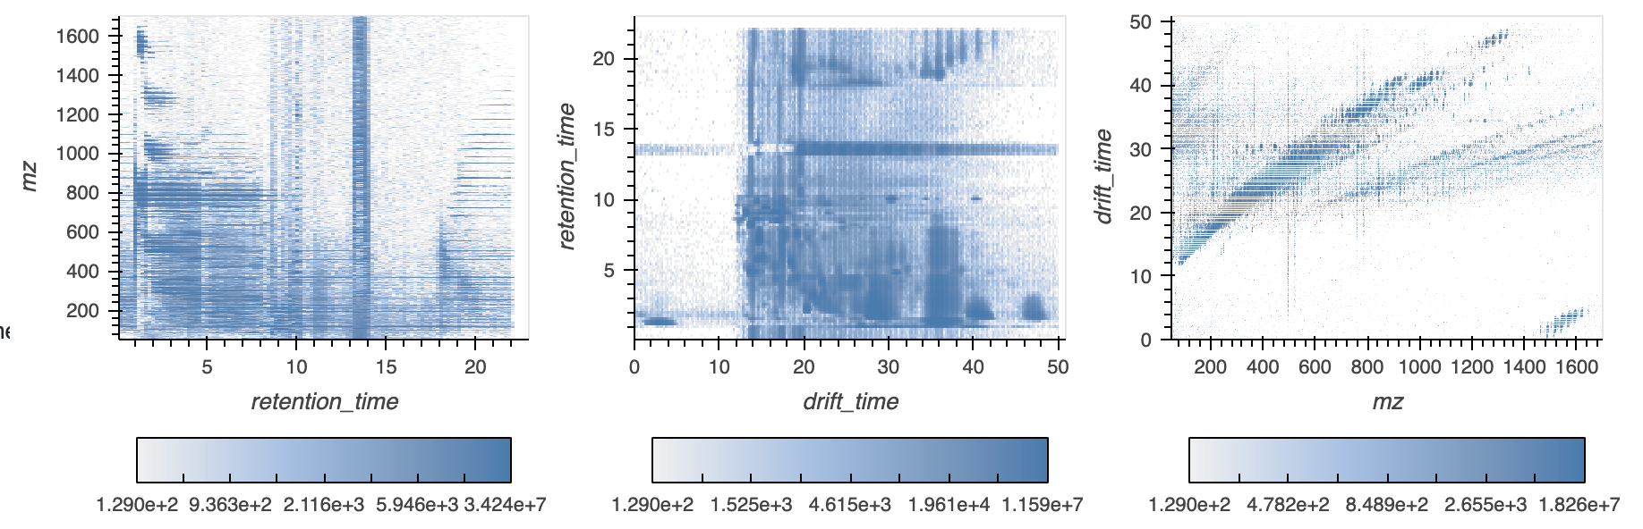

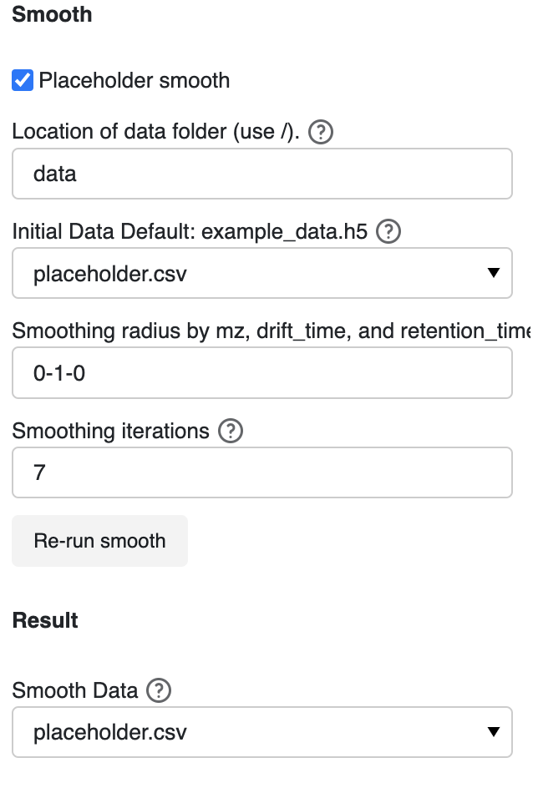

# Peak data:

Feature detection, also referred to as peak detection, is the process by which local maxima that fulfill certain criteria (such as sufficient signal-to-noise ratio) are located in the signal acquired by a given analytical instrument.

The original data is a placeholder, and unclicking it will trigger the peak function to run.

Click 'Run peak' after updating parameters to get new graph.

The radius per dimension insures an intensity-weighted per-dimension coordinate will be returned for each feature

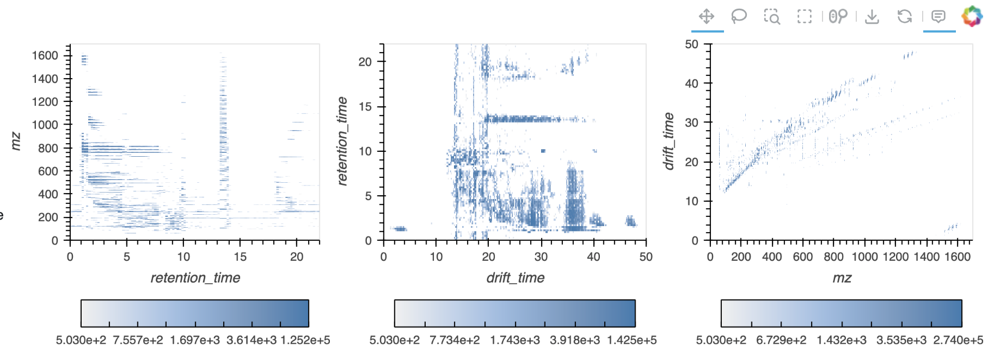

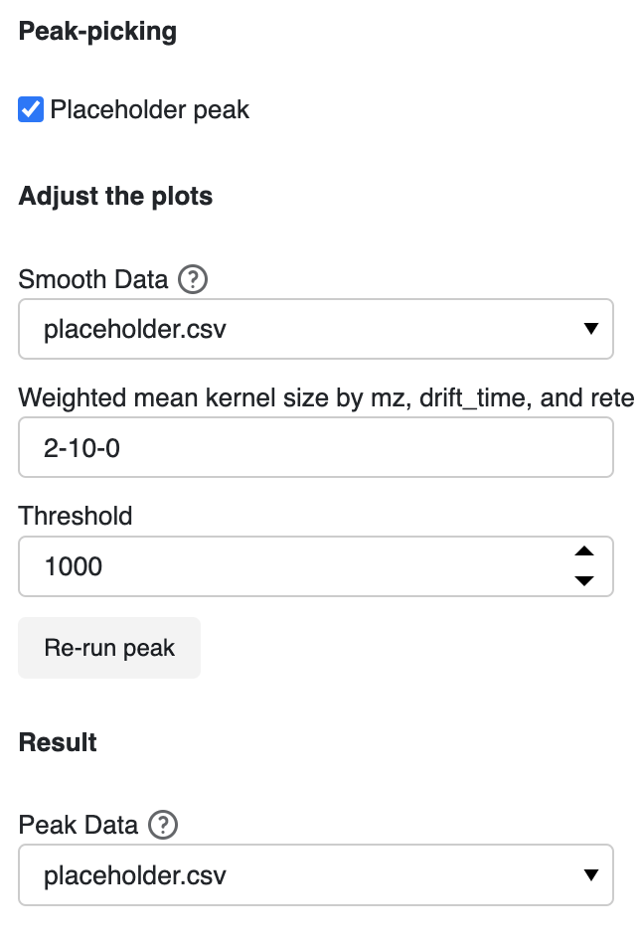

MS deconvolution

With MS1 features of interest determined by peak detection, corresponding tandem mass spectra, if available, must be extracted and assigned to the MS1 parent ion feature.

The original data is a placeholder, clicking with the placeholder will only return random data.

Click 'Run decon' after updating parameters to get new graph.

The MS2 data associated with user-selected MS1 data, with the MS1 data with the highest intensity used if there are multiple MS1 data points within a small range of the user-click

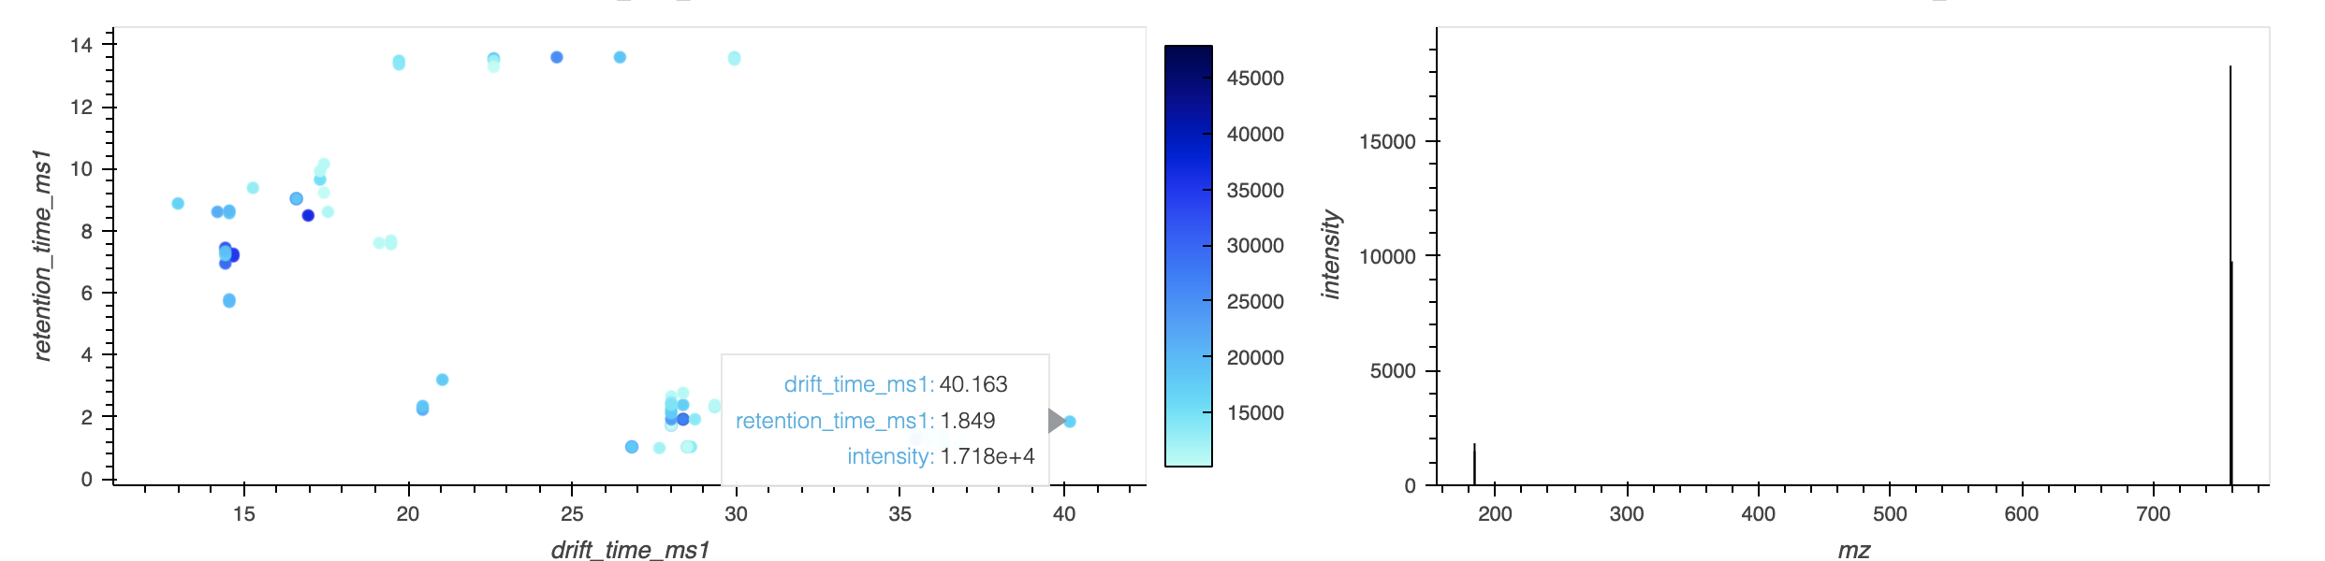

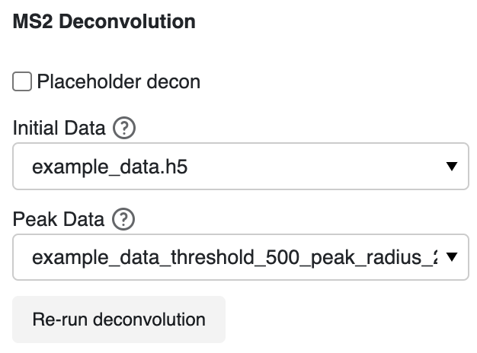

# Calibration

The calibrated file will be saved the “created data folder”. The data file must include mz, ccs, charge, and, if not tune mix, a ta column.

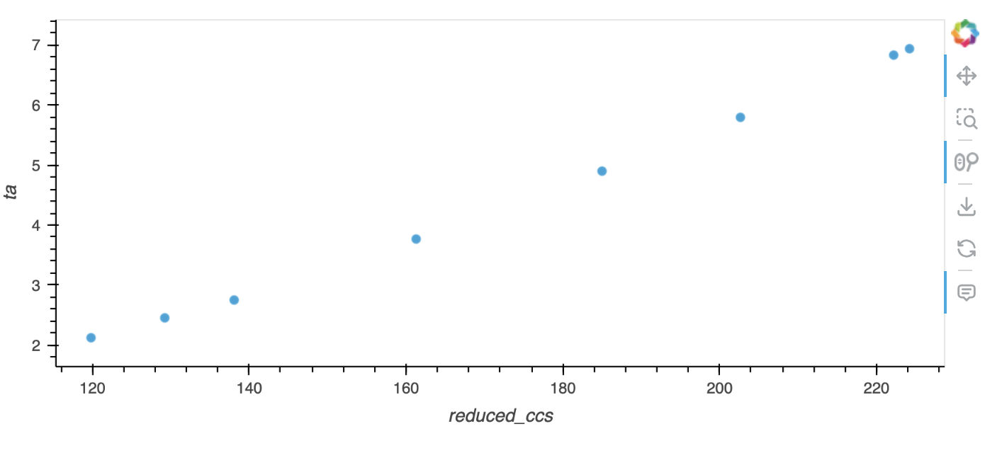

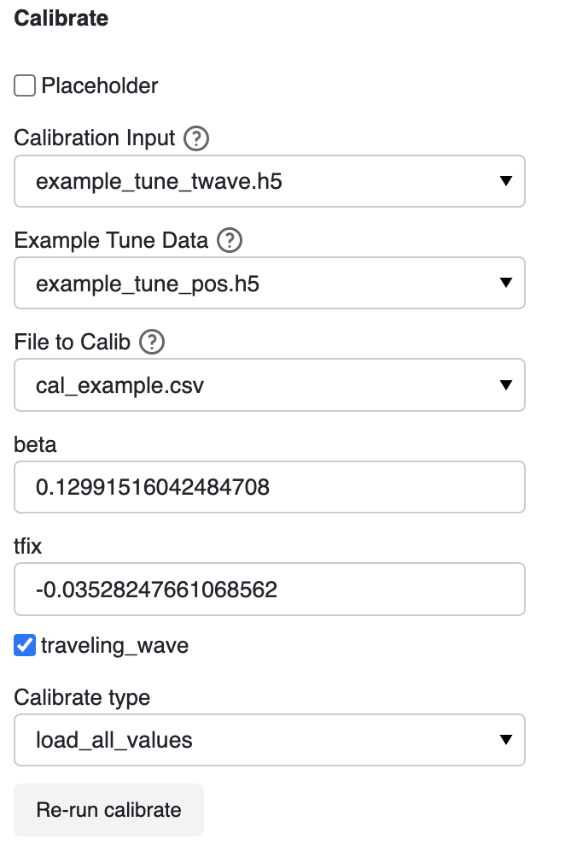

# Isotopes

Select a row in the data-frame to view the isotopes and a slice of the data around the isotopes, with the range of the slices determined by the user inputs for slice size

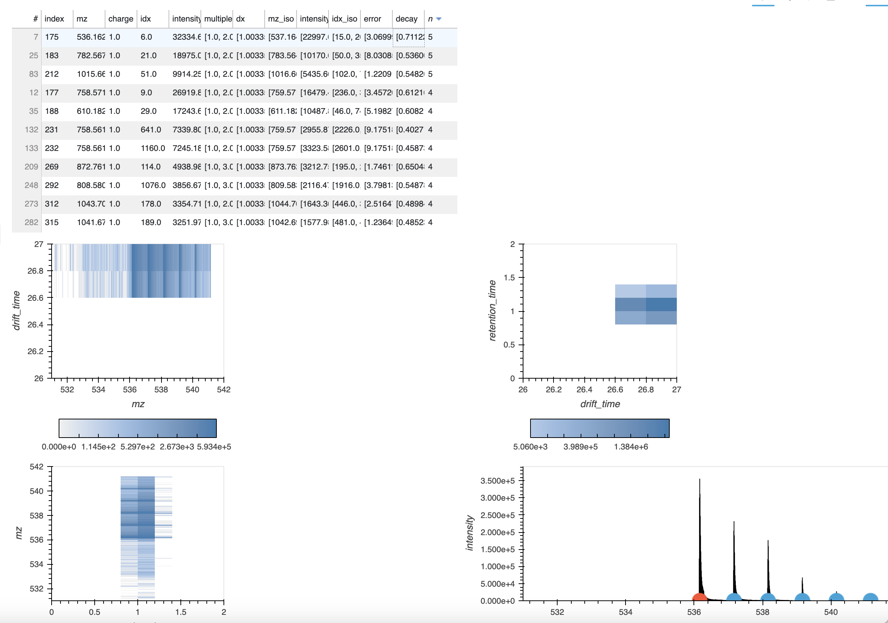



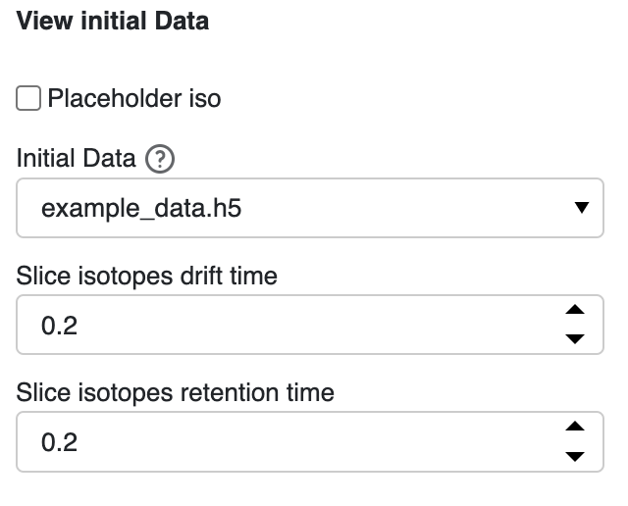

# Align

Update the name of the file to use as the reference

Update the peak folder location and indicate (with * as the wildcard) the ending of the files to use.

Alignment is the process by which feature coordinates across samples are adjusted to account for instrument variation such that matching features are aligned to adjust for small differences in coordinates

Determine matches within tolerance per feature with the alignment determined by the kernel by relative or absolute value by support vector regression kernel.

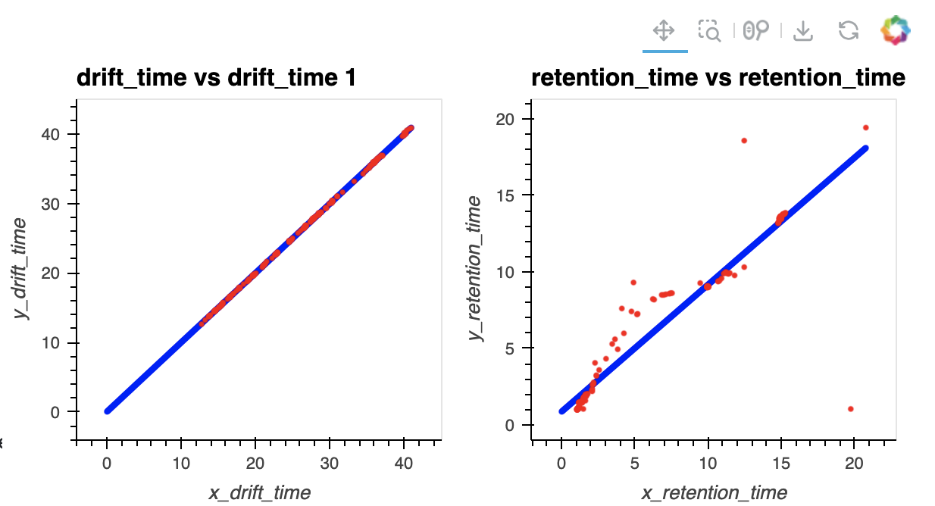

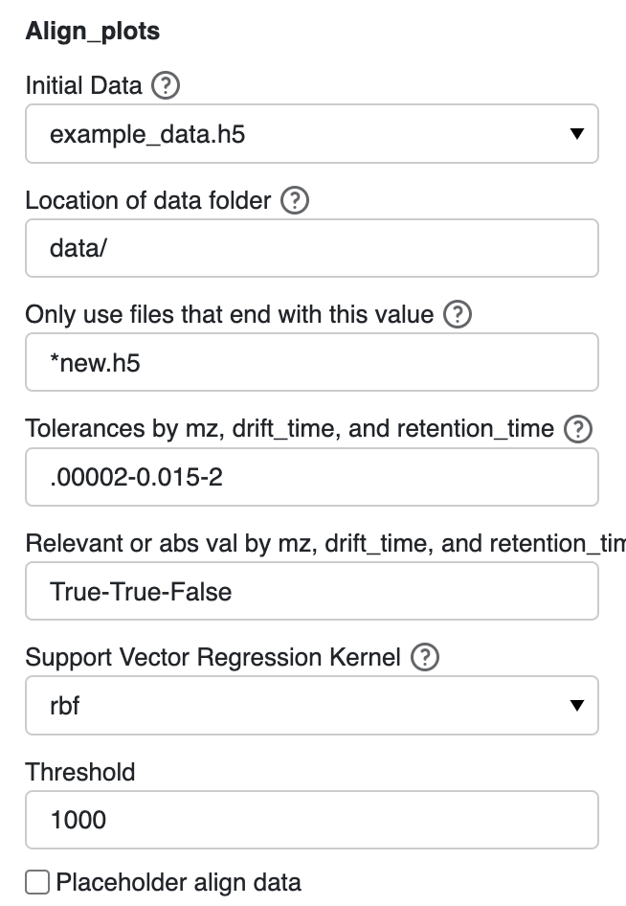

Extra:

“bokeh.core.serialization.DeserializationError: can't resolve reference warning” seem to occur when the align plots are updated. According to <https://discourse.bokeh.org/t/bug-with-deserializationerror-when-changing-content-layout-in-bokeh-3-1-1/10566> and <https://github.com/bokeh/bokeh/issues/13229>, it occurs when a layout is updated with new plots, and it is usually not something to be concerned about.